1. Suppose that $θ=-\frac{π}{4}:\frac{π}{20}:\frac{π}{4}$, and *t* = 0:0.2:2, *a* = 5, and *b* = 3. Use MATLAB code to compute the following expression:

**(a)** . (b) 

(Answer with the program only).

Plot the following functions (c)  , and

(d) . Hint: choose steps by yourself.

1. The following tables show the costs associated with a certain product and

the production volume for the four quarters of the business year. Use MATLAB

to find (*a*) the quarterly costs for materials, labor, and transportation; (*b*) the total material, labor, and transportation costs for the year; and (*c*) the total quarterly costs.

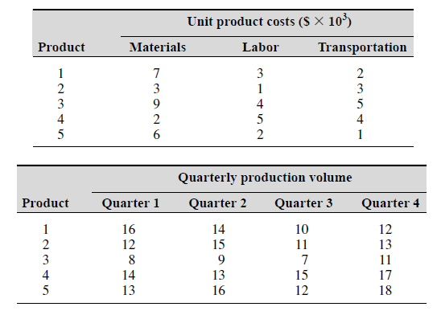

Ans:

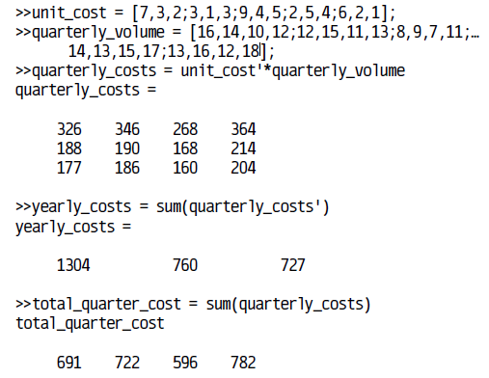

1. A water tank consists of a cylindrical part of radius *r* and height *h* and ahemispherical top. The tank is to be constructed to hold 600  when the water is full. The surface area of the cylindrical part is  and its volume is . The surface area of the hemispherical top is given by , and its volume is given by . The cost to construct the cylindrical part of the tank is $400 per square meter of surface area; the hemispherical part costs $600 per square meter. Use the **fminbnd** function to compute the radius that results in the least cost. Compute the corresponding height *h*.

